**Mastering Azure Data factory – UDEMY Course**

**Activities / Dataflows:**

1. **Copy activity –** Copied a file from Blob storage to ADLS gen2 and then inserted the records into a SQL database table.

1. **Copy missing files –** This activity involves copying the missing files that left out during the initial copy. Used get metadata activity to get the source and target file counts. Used filter activity to filter metadata child items and copy them using if activity.  
     
   **A screenshot of a computer

   AI-generated content may be incorrect.**
2. **Conditional Split transformation –** Performed conditional split based on a product data set and splitting into ‘Instock’, ‘OutOfStock’ and ‘DiscontinuedItem’.  
     
   **A screenshot of a computer

   AI-generated content may be incorrect.**
3. **Aggregate transformation –** Performed aggregate operations like Max, Min, Sum, Avg on a regular employee dataset on group by employee department.  
   **A screenshot of a computer

   AI-generated content may be incorrect.**
4. **Derived transformation –** Performed derived transformation to manipulate the employee gender and added new column based on employee salary.  
     
   **A black and white screen with white text

   AI-generated content may be incorrect.**
5. **Dynamic copy activity –** Dynamically copying the files looping through child items using get metadata activity and as well logging the pipeline run using stored procedure written in SQL db.  
     
   **A screenshot of a computer

   AI-generated content may be incorrect.**
6. **Exists Transformation –** Performed exists transformation that returned the matching rows of the left table and comparing it with right table.   
     
   **A screenshot of a computer

   AI-generated content may be incorrect.**
7. **Filter transformation –** Performed regular filter transformation on employee dataset to return manager data.  
     
   **A screen shot of a computer

   AI-generated content may be incorrect.**
8. **Flatten transformation –** Read the JSON source data set and flattened its array object using flatten transformation.  
     
   **A screenshot of a computer

   AI-generated content may be incorrect.**

1. **Join transformation –** Performed all types of join like left, right, inner and full outer join using joiner transformation.  
     
   **A screenshot of a computer

   AI-generated content may be incorrect.**
2. **Lookup transformation –** Performed lookup transformation to lookup department table and return only one instance for each match.  
     
   **A screenshot of a computer

   AI-generated content may be incorrect.**
3. **Multi delimited file handling –** Read the csv file with multi delimited, used split operation to split based on limiters using derived transformation  
     
   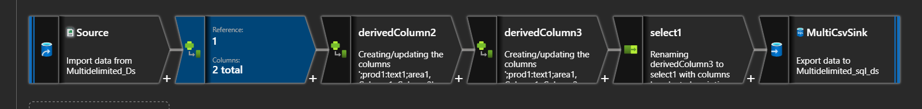

1. **Pivot transformation –** Performed to row to column transformation in counting the number of employees group by department id , pivot key and pivoted columns.  
     
   **A screenshot of a computer program

   AI-generated content may be incorrect.**
2. **Rank transformation –** Performed regular rank transformation of max salaried employees by department  
     
   **A screenshot of a computer

   AI-generated content may be incorrect.**
3. **Select transformation –** Performed select on columns and renamed some using select transformation.  
     
   **A screenshot of a computer

   AI-generated content may be incorrect.**
4. **Surrogate key transformation –** Generated surrogate key for the table with no primary key  
     
   **A screenshot of a black box with white text

   AI-generated content may be incorrect.**

1. **Union transformation –** Performed union transformation to union all on two tables and understood that ADF unions tables on key column but regardless of structure and no.of.columns  
     
   **A screenshot of a computer

   AI-generated content may be incorrect.**
2. **Unpivot transformation –** Performed unpivot on pivoted output make ungrouped by, unpivot key and columns  
     
   **A screenshot of a computer

   AI-generated content may be incorrect.**
3. **Window transformation –** Used window transformation to aggregate without group by and calculated and ranked top 3 salaries on Employee table  
     
   **A black and white screen

   AI-generated content may be incorrect.**

**Understood and played around with activities that are mentioned below:  
  
**

**Worked on incremental loads using stored procedure:**

**SCD type-1**

**SCD type-2**

**SCD Type3**

